Mid Term Report

2 Holmesdale House London NW6 4QU

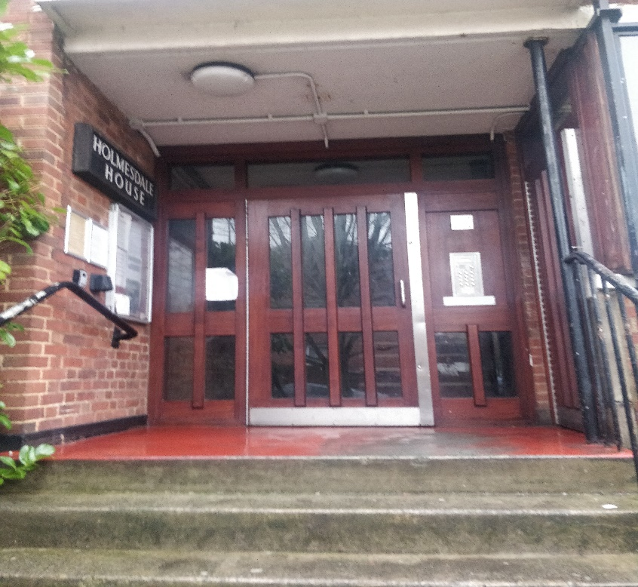

Tenancy: 13th August - Present
Landlord: Tulika Raj
Report completed on: 11.12.2020
Report completed by: Scott McCorquodale

Inspection Details
Tenants present at time of inspection: Yes
Weather conditions at time of inspection: Dry
General Property Summary
General standard of cleanliness: Untidy
Common Parts
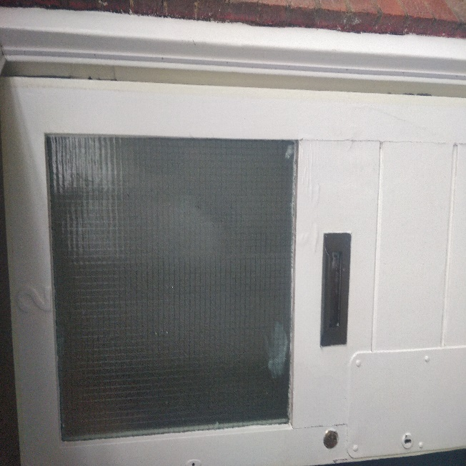

Entrance Hall
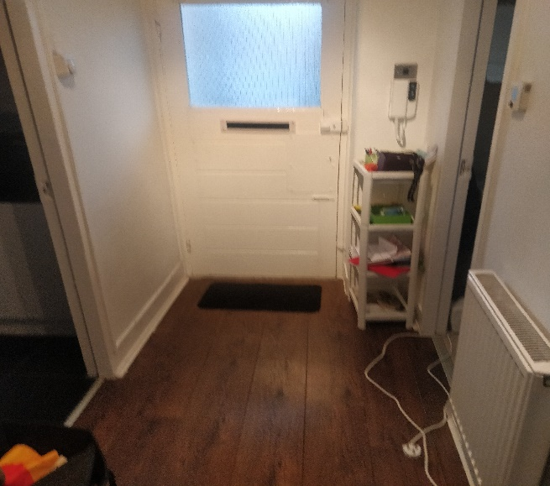

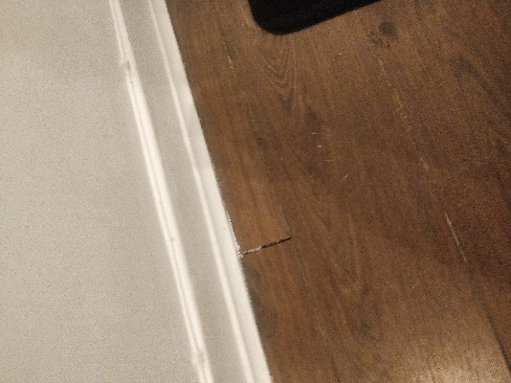

Slight gap between two boards in hallway flooring

Living Room/Bedroom
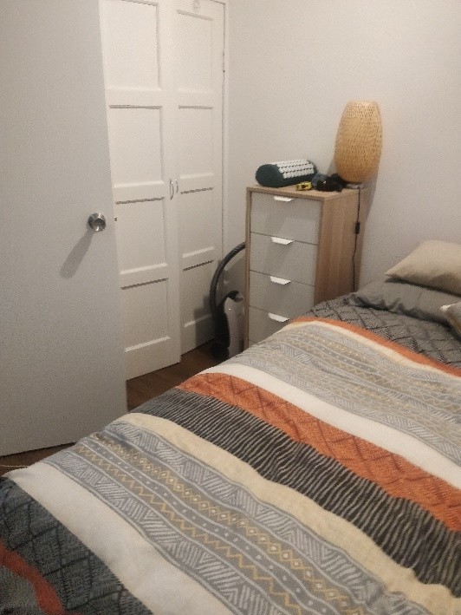
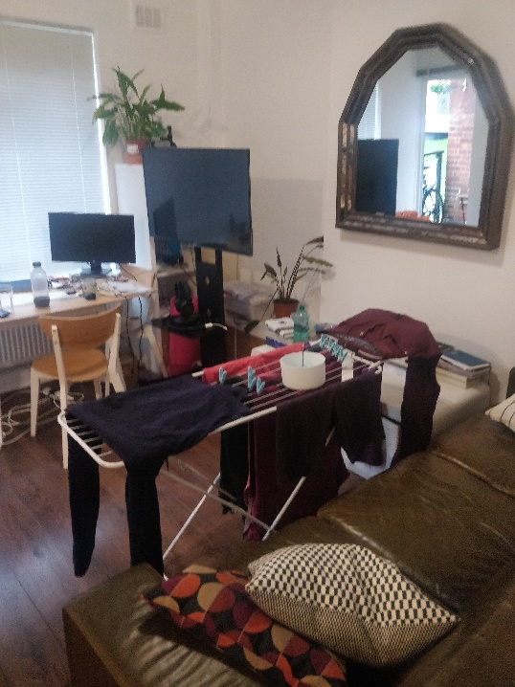

Kitchen
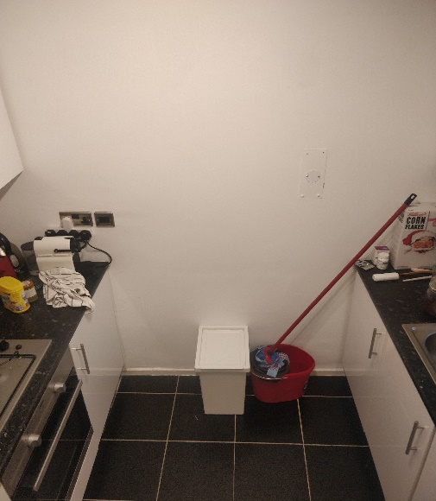

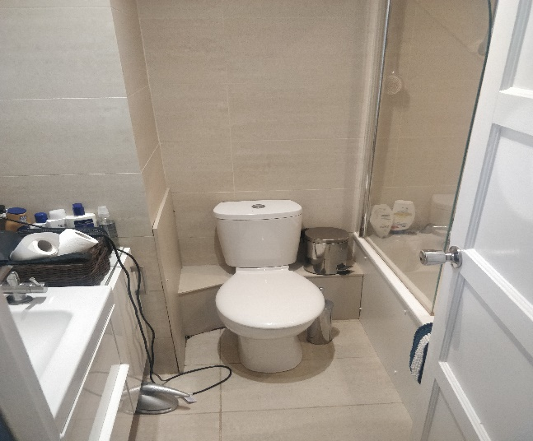
Bathroom

Health & Safety Notes
Smoke/Heat/CO2 Alarms Checked: Yes
Any trip Hazards: No
All internal and communal lighting working: Yes
Cleats fitted to blinds where applicable: Yes
Maintenance Report
Urgent attention needed: N/A
Advisory Attention needed: Repair pop up mechanism to bath plug. Install splash back to protect wall paint behind hob.

